In this section, we provide numerical results for the proposed D2D method, the non-D2D method, and a reference greedy non-D2D method, which based on current CSI only. In the reference non-D2D method, in each time slot, we find and choose  boats that have highest speed under given BS power and current CSI.

As for the simulation parameters, the BS is located in the central position  at the  plane, and the boats traverse along two intersecting shipping lanes. Moreover, the two lanes have same number of boats. Boats leave the harbors every 15 minutes, and all sail at the speed of . We assume that the system uses a carrier frequency of , and has a total bandwidth of for 10 subcarriers. The BS power for non-D2D transmission is set to be  whereas the boats have  for D2D transmission, since they are arguably smaller. The antenna height of the BS and the ships is  and  respectively.

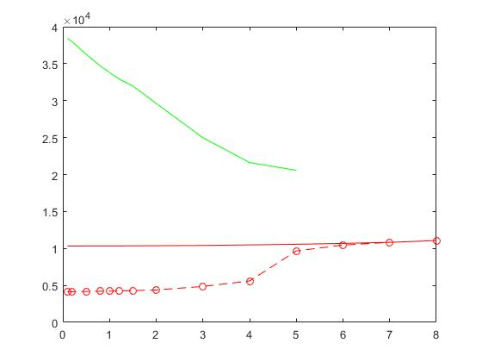

Fig. xx shows the bit-wise average power consumption under different QoS constraint. As we can see, our proposed D2D method outmatch the non-D2D method and the reference method, especially when there is a smaller QoS constraint. The proposed D2D method approaches the non-D2D method when the QoS constraint gets relatively large. This is because the non-D2D part might take up too many of the feasible D2D time slots and left the D2D method few good time slot choices for optimization. The reference method’s energy consumption gets smaller as the QoS constraint get larger since the reference method is a greedy one, and it aims to meet the QoS constraint as soon as possible. This may result in a larger proportion of chosen time slots with relatively low speed when the QoS constraint is lower. In addition, the proposed method can deal with larger QoS constraint  than the reference method .

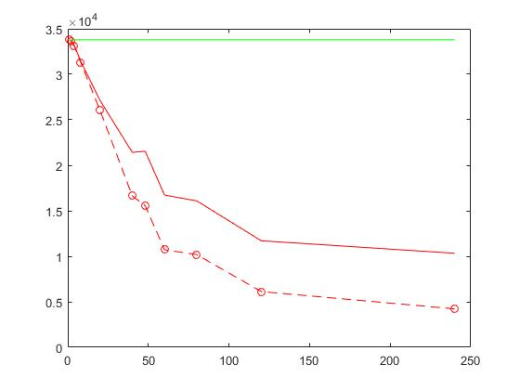

Fig. xx demonstrates the relationship between average energy consumption and the number of time slots whose CSI we can acquire in advance, i.e., the time range . When we can only acquire present CSI, our proposed method retrogress to the reference method. The more time slots whose CSI we can know in advance, the more feasible transmission time slots we can choose from in our method and therefore the more improvement we can get from our time-aware D2D and non-D2D methods.

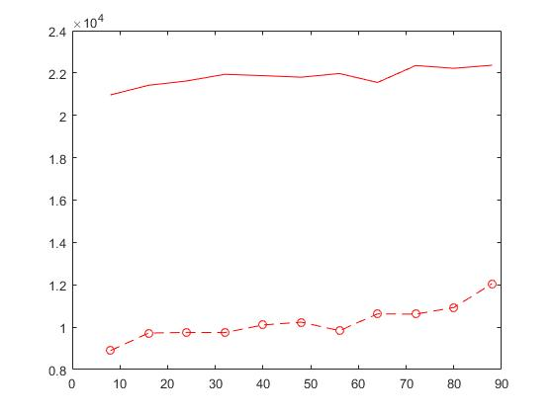

Total user count versus average energy consumption is shown in Fig. xx. This time we consider half of the boats to be still in the BS coverage, while the other quarters still traverse along the shipping lanes at . Boats leave harbors more often as the total boat count increase. Our proposed D2D method is much better than the non-D2D method energy-wise. Both D2D and non-D2D average energy consumption increase as the user count increases. The reason is that there may be insufficient subcarriers to serve the users on their best channel conditions when the user count get larger than subcarriers.